**Exploring Washington Park Public Health**

Table of Contents

Abstract 1

Research Question 3

Descriptive Statistics Analysis 4

Result 12

Summary 12

Appendix 13

Citations 14

# Abstract

The major goals and objectives of this research project are to gather and present data sources that assist Chicago Youth Programs (CYP) to achieve its mission of keeping families together and to enhance the health and life opportunities of vulnerable youth using a comprehensive approach designed at developing the organization abilities to continue improving the quality of lives in the Washington Park Community. Health is about more than physical well-being. Health is determined by social and economic factors, the environment we live in, our behaviors, as well as health care quality and access to medical resources. Washington Park is a neighborhood in Chicago, Illinois with a population of 11,719. Washington Park is in Cook County as displayed in Figure 1. Eighty-seven percent of residents living in Washington Park rent their homes. Two of the primary medical issues in Washington Park Community are **teen birth rate** and **infant mortality rat**e. The teen birth rate in the United States is at a record low, below 18 births per 1,000 girls and women ages 15 to 19. Washington Park’s teen birth rate is a little less than, three times the National average, 43.7 per 1000. The infant mortality rate in the United Statesis 5.9 deaths per 1,000 live infant births. Washington Park’s infant mortality rate is 13.3 per 1000. We are going to perform a census tract-level analysis of the 77 communities in Cook County with Washington Park. There are a plethora of coffee shops and parks. Many families living in Washington Park tend to be socially liberal. Washington Park has experienced sharp rates of population loss, crime, and socioeconomic inequalities that reflect a community that is underserved. Data include information related to heath care involving families, access to health facilities and. covering general GIS concepts and theory, and the specific implantation of those concepts within ArcGIS and SPSS Desktop.

**Figure D**

**Overview Map of Washington Park**

The 8 block groups in the Washington Park, Cook County Neighborhood

# Research Question

Our intent in this report is to assist CYP to better understand any potential connections between community areas teen birth rate and infant mortality rate as related to health care involving Washington Park Families. In concert with factors that are highly related to CYP mission statement. The study uses GIS as a methodology for estimating service levels and representing them visually through “Identifying medical center locations in each community by comparing the locations of the slum clusters and the health facilities. As well as to estimate the service levels offered by some of the medical location” (Mavalandratta, et al). Essentially the GIS Maps assist with visually identify existing areas of the medical health care services along with the magnitude of medical issues in the communities CYP services.The CYP is an innovative program created by Northwestern University medical students in 1984, a non-profit organization serving the Washington Park Community of Chicago, Illinois. CYP services provide referrals, resources, and skills that encourage underserved families to be strong, self-sufficient, and remain intact.Data were collected from the American Community Survey, Chicago Area Metropolitan Planning agency, and the Chicago Data Portal regarding the Washington Park area of Cook County. To complete this project, we employed a quantitative analysis of the collected data and using the data to perform descriptive statistics to assist in understanding the risk factors of the families in the Washington Park Community. The following forms of spatial analysis will be used to achieve visualization of health and family well-being demographic data within the study area: This process portrays the selected features (in this case key demographics) within a gradient color scheme by the designated geographical feature. The maps display symbolization using changes in value and saturation points so that the increase in quantity is clear, as shown in population maps in Figure 4.8a, b, c. These tools assist with understanding the descriptive spatial statistics values for cells in a raster format from a limited number of sample data points.

**Methodology**

This Dataset was acquired from the Chicago Department of Public Health. It is owned by Epidemiology and Public Health Informatics, Chicago Department of Public Health Dataset. The

parameters were inspired by 77 observations and contain a subset of 3 parameters. A shapefile containing Chicago boundaries was downloaded and also uploaded into ArcMap. The two tables were then joined using the FID columns to add the data for the three variables into the table demonstrating the stated boundaries in Figure Z. Choropleth maps were created to assist with visualizing the variables for individual communities. The results of the quantitative choropleth maps are outlined in the descriptive statistics analysis section. A hot and cold spots analysis was conducted to identifying hot spots of teen birth rate existing in the community and Washington Park. In the process of data preparation, the set was also loaded in SPSS.

# Descriptive Statistics Analysis

**Figure A**

**Figure A:**  Observation infant mortality rate has an average of 8.57, Med = 8.10, Min = 1.5, Max = 22.6, Skewness = 0.782, Kurtosis = 0.445. Infant Mortality Rate histogram shows data appears to be multimodal. We are definitely seeing a leptokurtic distribution. This tends to a higher peak than normal. Also, there are possibilities of outliers.

**Figure B**

**Figure B:**  Observation teen birth rate has an average of 50.07 (SD = 28.10, Med = 49, Min = 1.3, Max = 116.9.00, Skewness = 0.06, Kurtosis = -0.59). Teen Birth Rate histogram shows data appears to be multimodal. Here we can see a leptokurtic distribution. This trend to a higher peak than normal. Also, there are possibilities of outliers. There is symmetry. The lowest Teen Birth Rate is 92 and the highest Teen Birth Rate is 120.

**Figure C**

Figure C: Descriptive Statistics for Infant Mortality rate and Teenager Birth Rate

Kolmogorov-Smirnov tests were conducted to determine whether the distributions of the teen birth rate and infant mortality rate were significantly different from a normal distribution. The following variables had distributions which did not significantly differ from normality: teen birth rate (Test-Statistic = 0.07, p = .871) and infant mortality rate (Test-Statistic = 0.12, p = .238). The observations for teen birth rate had an average of 50.06 (SD = 28.10, SEM = 3.20, Min = 1.30, Max = 116.90, Skewness = 0.18, Kurtosis = -0.43, median = 49.20, Mode = 68.20). The observations for infant mortality rate had an average of 8.57 (SD = 4.41, SEM = 0.50, Min = 1.50, Max = 22.60, Skewness = 0.77, Kurtosis = 0.34, median = 8.10, Mode = 5.40). (Westfall & Henning, 2013). The summary statistics can be found in Table 2. A Pearson correlation requires that the relationship between each pair of variables is linear (Conover & Iman, 1981). This assumption is violated if there is curvature among the points on the scatterplot between any pair of variables. Figure2 presents the scatterplot of the correlation. A regression line has been added to assist the interpretation. It appears our data satisfies the four parametric tests based on normal distribution i.e., interval or ratio level data, independent, normality, and homoscedasticity.

**Figure 2**

*Scatterplots between each variable with the regression line added*

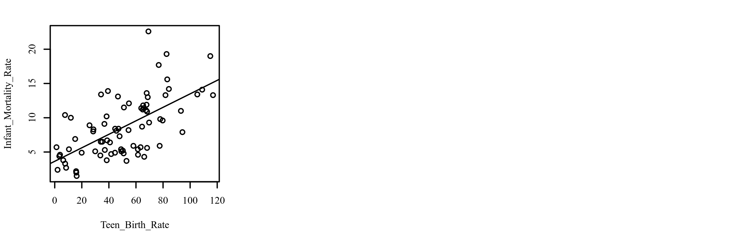

Since we know from Kolmogorov-Smirnov tests that our variables follow the Gaussian/Normal distributions which did not significantly differ from normality hypothesis statement is the mean value of teen birth in Washington Park, Cook County no different from the mean value of the National population of 18.0 per 1000. Since the mean value of Washington Park is 43.7 per 1000 and not close to the National population mean, our likely conclusion is that we would reject the null hypothesis by concluding that alternative hypothesis is true and

H0: µ equal 18

HA: µ not equal 18

there is a statistically significant difference, and most likely with a p-value< =0.05at the standard 95% level.

Figure 3 Box Plot for Infant Mortality Rate

It appears West Garfield Park has an outlier of 22.5 and the mean Infant Mortality Rate is 8.5

Figure 4 boxplot for **mean Teen Birth Rate is 50.1**

**Figure 4.8 A**

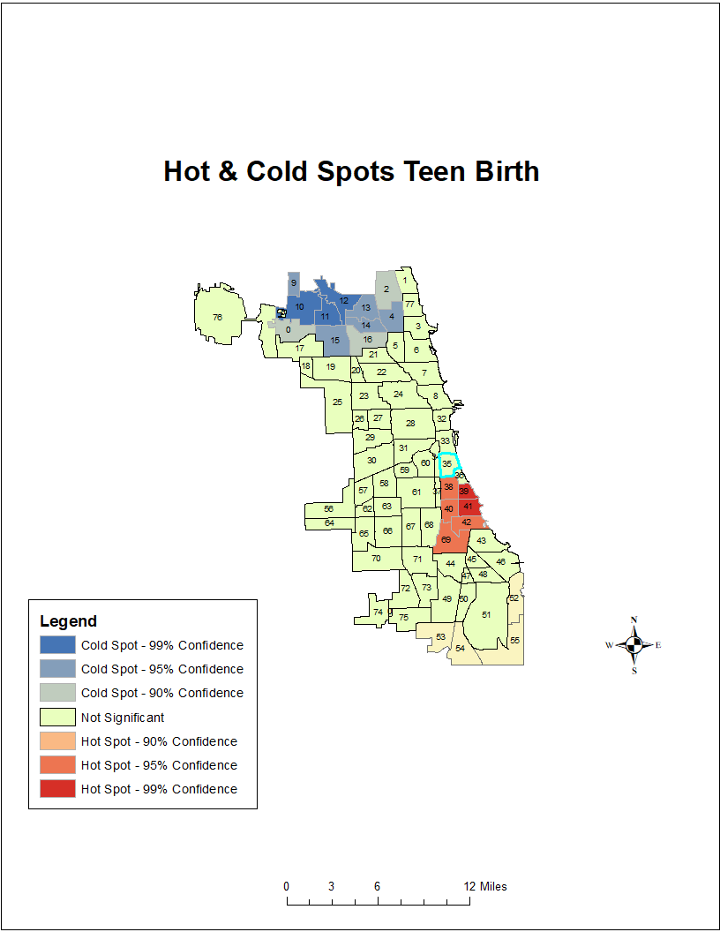

**Figure 4.8 B**

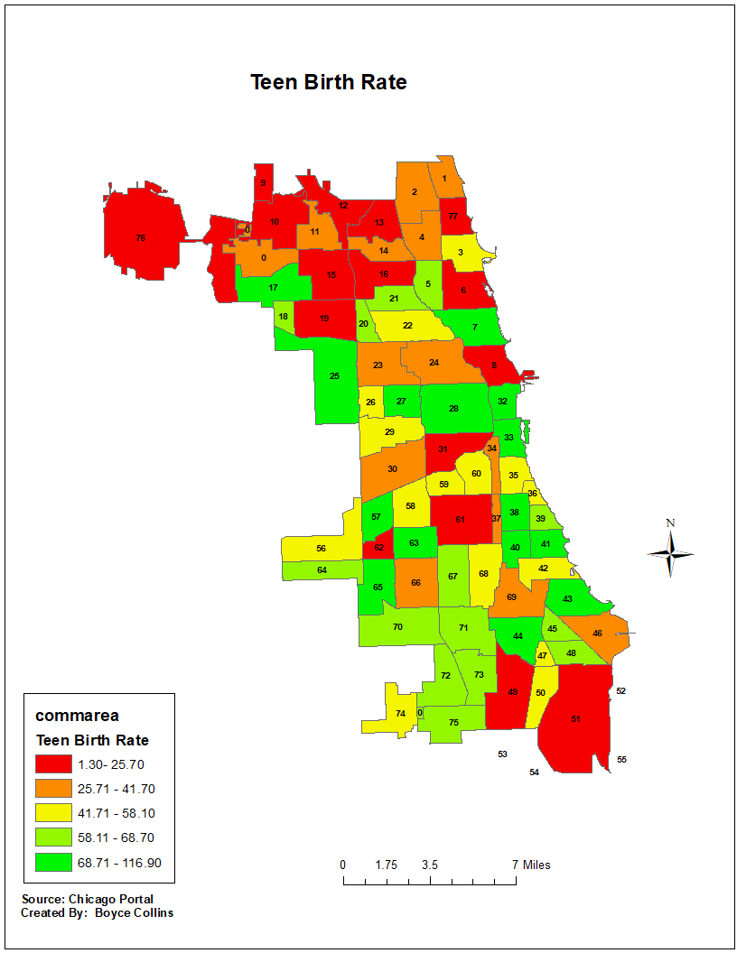

**Figure 4.8 C**

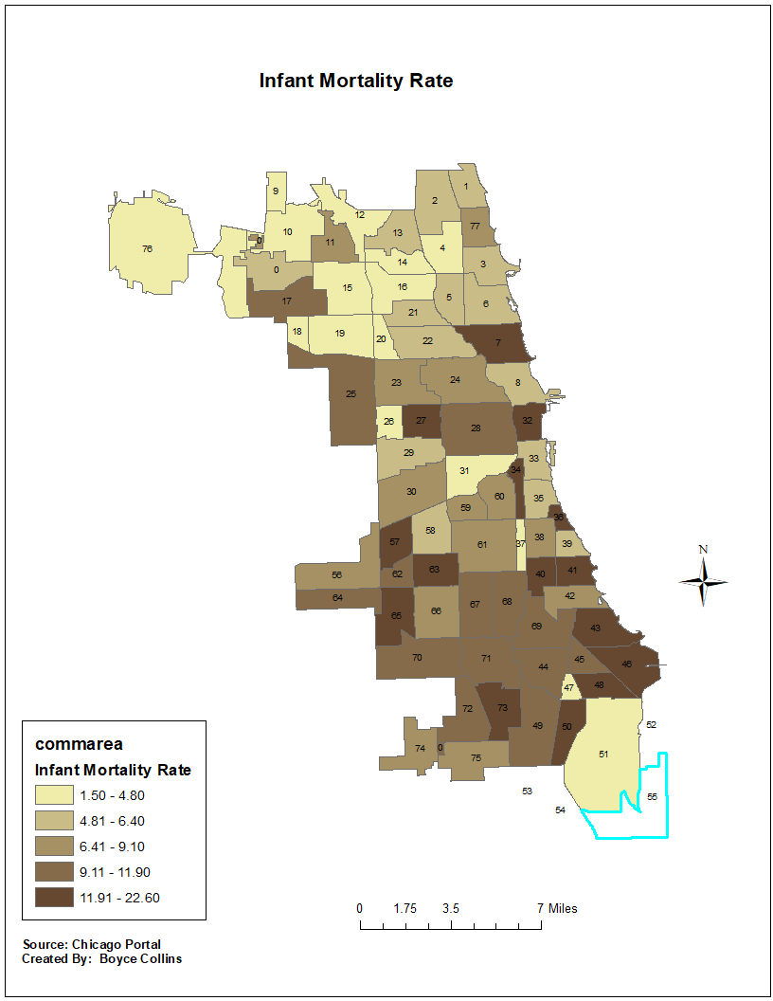

**Figure 2**

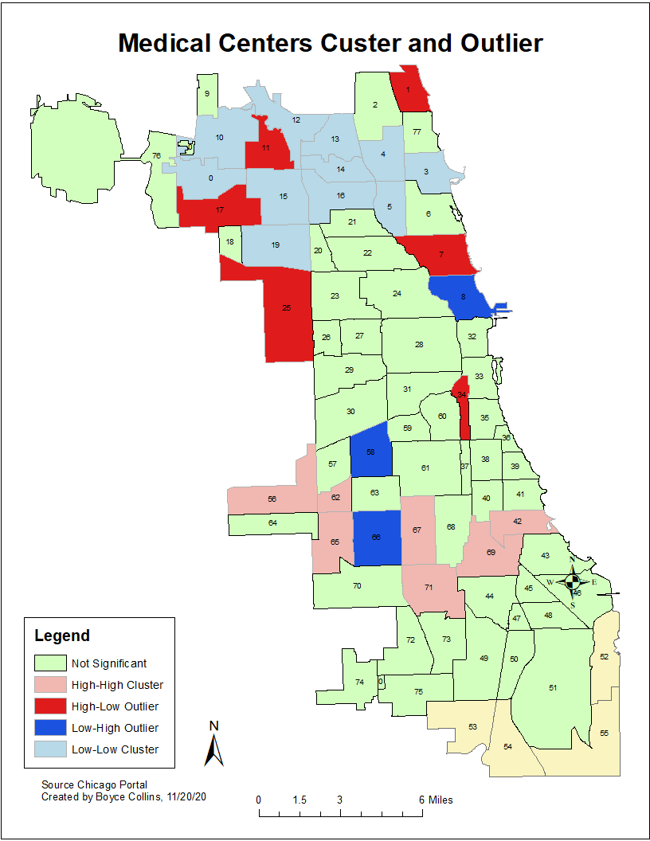

There are one full level one trauma centers and medical center that is in close proximity to Washington Park census tract, and its hospital system is comprised of John H.

Stroger Jr. Hospital of Cook County, Oak Forest Health Center, County Care, Provident Hospital of Cook County, the Cook County. University of Chicago is the only level 1 trauma center for children, Comer is affiliated with the University of Chicago, and so is St. Bernard Hospital.

Provident Hospital of Cook County is an eighty-five (85) bed hospital in Cook County Health

# Result

The several maps we produced for this project (including the final Vulnerability Map) show that there are areas within the Washington Park neighborhood that are higher in the likelihood of having children who will end up in the foster care system than in others based on four indicators: youth (percent of the population under the age of 25), household poverty (percent of the household population below $27,086 annual income), proximity to crimes involving children. These upshots show that the edge snapping counties on the west ends have similar teen birth rates vulnerability rating than those in the west and eastern areas. There are also generally seems to be a band of higher vulnerability in the northern portion of the neighborhood.

# Summary

The Washington Park neighborhood is a community that faces severe systemic challenges that most other neighborhoods in the City of Chicago never face. With a high rate of crime to low educational attainability, these challenges require extensive allocation of resources and services that target the families of the community. The CYP is a community organization that is directly

serving the Washington Park residents and actively making strides in making this community the best it can be. Through their programming and services, the Chicago Youth Programs is recommended to utilize this report to support their Targeted Recruitment Effort which will be used to “reduce the trauma of out-of-home placement, by keeping families connected to their communities, schools, places of worship, and family when safe to do so”.

The results provided in this project report is only suggestive recommendations that CYP’s services and resources can use in key target areas to respond to the factors that are correlated with the continuous high teen birth rate and high infant Mortality above the National average. We recommend that the Target Recruitment Effort, and additional utilization of CYP resources and service, focus on the entire northeastern corridor of the neighborhoods where the vulnerability is the highest. By homing in on this portion of the neighborhood CYP can effectively and efficiently serve those most in need while also continuing their exceptional work in serving the entirety of the Washington Park Neighborhood and successfully increase the quality of health care and education.

# Appendix

|  |  |  |
| --- | --- | --- |
| **Name** | **Type** | **Description** |
| Teen Birth Rate | Quantitative/ratio  Discrete continuous variable with a type of interval, Scale | Per 1000 Females aged 15-19 |
| Infant Mortality Rate | Quantitative/ratio  Discrete continuous variable with a type of interval, Scale | Per 1,000 live births |
| Community | Categorical/Qualitative/nominal | Chicago Communities |

# Citations

Westfall, P. H., & Henning, K. S. S. (2013). *Texts in statistical science: Understanding advanced statistical methods.* Taylor & Francis.

Community Data Snapshot Washington Park. Survey/Program American Community Survey Retrieved

from: <https://www.cmap.illinois.gov/documents/10180/126764/Washington+Park.pdf>

Chicago Youth Programs / CYP Website. (2020) Retrieved from: <https://www.chicagoyouthcenters.org>

HealthData.gov <https://healthdata.gov/dataset/hospitals-chicago/resource/2ff8c778-25bb-4ac2-b602-d94d905af793>

<https://www.chicagohealthatlas.org>

Census tract-level counts and estimates obtained from the U.S. Census Bureau 2000 census,

2010 census, and 2006-2010 American Community Survey

https://data.cityofchicago.org/Health-Human-Services/Public-Health-Statistics-Selected-public-health-in/iqnk-2tcu

<https://www.pewresearch.org/>

J. Chapman McGrew, Jr. Statistical Problem Solving in Geography, 3rd

**֎.**